Nicholas Schuhmacher

Chapter 3 page 183 exercise 2

1. Download Visualization_MFG_Sample data set (available as an Excel file on this book’s Web site). Using Excel or any other software tools made available to you in your institution, answer the following questions:
a. What is the relationship between gross box office revenue and other movie-related parameters given in the data set? The gross box office is connected to opening week, gross box, and our classgrossbox. The revenue is connected in a direct and dependent way as we can see that the total revenue is dependent on the performance of other variables as well as it plays a part in larger categories and variables.
b. How does this relationship vary across different years? Prepare a professional-looking written report that is enhanced with screenshots of your graphic findings.
We can see that there is a relationship between the time of year and the gross revenue. My hypothesis is that we see an increase in box office revenue and attendance around holidays. The graph shows a pattern that helps reinforce that notion as we can see an increase in revenue around times when people are home for holidays or breaks, more specifically, times when schools are out. We can see during the summer, Thanksgiving, and winter break season, that the attendance and revenue spike. This leads me to believe that there is a direct connection between time of year and the box office.
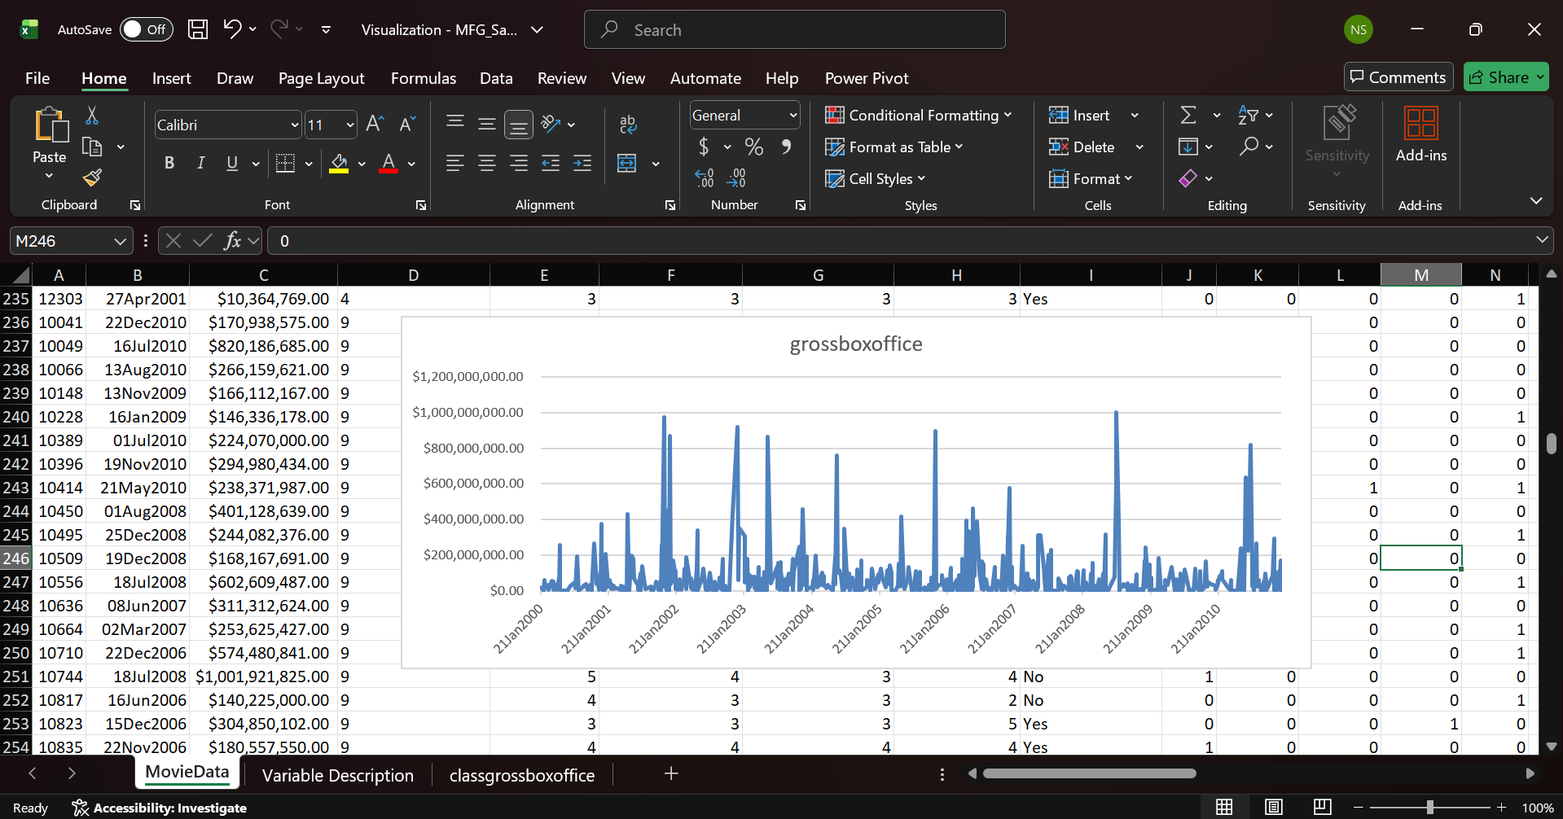

Chapter 4 Exercise

Coca-Cola Japan puts the fizz back in vending machine sales

Evaluation and questions

- What is the purpose of the data warehouse?
The Data warehouse is designed to take in the vending machine data from all companies and individuals and putting this data into an environment that they can easily access and make changes to while still keeping it secure and easy to navigate.

- What is a wireless network? How does it facilitate computerized decision support?
A wireless network is a computer network that sends signals through the air that allows it to communicate and have access to other items or devices on the network. As well as it allows devices and other networks items to access the internet. This allows users to quickly and easily access databases and make decisions based off of the networks performance and devices sharing information on the network.

3. Is the enterprise data warehouse part of a data-driven Decision Support System? Why or why not? Yes the data warehouse is a integral part of the decision support system and is used to provide centralized analytics, reporting, as well as making informed decisions.
4. Is the Column Management System a DSS?
Yes management is a part of dss and is useful for making sure that data is presented and shown in a way that is easily accessible and understandable.
5. What decision support technologies were used?
We have a couple of technologies, as we can see, and we use management practices and many data-based tools like data warehouses and networks.
6. Does the data warehouse support any transaction processing?
No normal data warehouses to my understanding that they are not set up for transactional processing and are not set up for real time interactions.
7. What is the major benefit of the enterprise data warehouse (EDW)? Why?
It allows you to have and make better decisions by using and having access to more data. Allowing us to have a centralized database allows us to make better decisions based on the whole database.
8. Should other soft drink vendors create this type of decision support capability? Is it viable in Europe, USA? Why or why not?
I think it is a very good and very useful method that Japan has come up with and I think for their purposes and the culture of Japan it works very well. I could see Europe maybe implementing it but not the US as we have such a competitive and capitalistic market that I could not see businesses working together as well as we do not have a very big “vending machine culture”.
9. What problems or difficulties do you anticipate with the use of this type of decision support solution?
I could see issue arising in the fact that since they are using one centralized database, if a individual or group was not pleased with things or felt like sabotage, they have access to everything and can alter everything as well as I could see that if someone makes a not so informed decision it could have major implications on the rest of the data or business.

